Respond to a Concern

Checklist for a Responding to Concerns procedure

It can be very difficult to know what to do if faced with a concern about a child or young person, especially if the concern involves someone you know. This procedure ensures that everyone in your club is clear on what action to take in the event of a child wellbeing or child protection concern. It gives volunteers and members of staff clear, important steps to follow, ensuring action is taken quickly and in the best interests of children and young people.

Defining child wellbeing concerns
Child wellbeing concerns are those that, in isolation, do not always meet the threshold for a child protection referral but still have an impact on the wellbeing of the child or young person. A range of experiences can have negative effects on children and young people, for example bullying, mental health concerns, bereavement, family separation or parents pushing their child too hard in sport.

There may also be scenarios where a volunteer or member of staff could have an impact on the wellbeing of a child or young person due to their poor practice. Examples may include shouting aggressively, punishing children and young people through extra drills/exercises, singling children and young people out in front of peers for minor things such as leaving kit behind, or communicating with children and young people through a personal social media account.

It is important to note that child wellbeing concerns may, with further exploration, or over time, escalate to become more significant child protection concerns and therefore it is important to respond appropriately and at the earliest opportunity.

Defining child protection concerns
In this context, a child protection concern is where it is believed that a child or young person may have been abused. Such a concern meets the threshold for an immediate referral to the statutory agencies, which will allow an investigation by the appropriate professionals to take place.

Principles underpinning responding to child wellbeing and protection concerns

- The wellbeing of the child is the paramount consideration.
- Parents/carers have the primary responsibility for the safety and wellbeing of their children and where possible the club should work in partnership with parents/carers when there are concerns about a child or young person.
- Children have the right to say what they think in all matters affecting them and to have their views taken into account (Article 12, UNCRC). It is important therefore to seek the views of the child or young person and, where relevant and appropriate, to seek their consent for further reporting of the concern.
- Where the concern about a child or young person’s wellbeing suggests that they are in need of protection, the information must be passed on to police/social work with or without the child’s consent for the purposes of their protection.
- Allegations of abuse must always be taken seriously. No member of [Organisation name] shall investigate allegations of abuse or decide whether or not a child or young person has been abused.

Ways a child wellbeing or protection concern may arise
A concern about a child may come to the attention of an adult in the sport through a number of different ways:
- a direct disclosure by a child
- through observation of a child, demonstrated by a change in their behaviour, appearance or nature
- information that is shared by another individual (adult or child) or organisation.

When faced with a child wellbeing or child protection concern, always:

Respond Record Report

What to do if there is wellbeing concern about a child

Respond

Any wellbeing concern about a child will be in relation to one or more of the wellbeing indicators – SHANARRI. For example, if a child seems withdrawn, they may have experienced an upset in the family, such as a parental separation, divorce or bereavement.
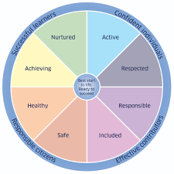
Wellbeing concerns will always be discussed with the child or young person, and their view taken into account. Parents/carers have the primary responsibility for the safety and wellbeing of their children and, as such, wellbeing concerns should also be discussed with them.

Common sense is advised in these situations and the best interests of the child will be considered as to what is the best way forward for each individual child. Where appropriate, consent should be gained from the child with regard to future actions and further support.

Record

A written record of the wellbeing concern will be made as soon as possible using the Concern Recording Form, completing as much of the form as possible. Where the form is completed electronically, it will be password protected and saved to a file that is only accessible by the Child Wellbeing and Protection Officer (CWPO) for [Organisation name] and [insert remits of others with access]. The record will be passed to the CWPO that day.

Report

All wellbeing concerns will be reported to the CWPO as soon as possible and the appropriate course of action agreed.

At any point, if there is uncertainty about the appropriate course of action, advice should be sought from the Child Wellbeing and Protection Officer.

What to do if there is a concern about abuse

No member of the club shall investigate allegations of abuse or decide whether or not a child has been abused.

Respond

Allegations of abuse will always be taken seriously. If a child says or indicates they are being abused or information is obtained which gives concern that a child is being abused, the information will be responded to on the same day.

How to respond if a child discloses abuse

Good practice:
- React calmly so as not to frighten the child or young person.
- Consider what requirements a child or young person may need to communicate effectively (e.g., do they have any additional support needs, is English their first language, etc.).
- Listen to the child or young person and take what they say seriously. Do not show disbelief.
- Reassure the child or young person they are not to blame and were right to tell someone.
- Avoid asking any questions. If necessary, only ask enough questions to gain basic information to establish the possibility that abuse may have occurred. Only use open-ended, non-leading questions, e.g. Who? What? Where? When?
- It’s important to explain to the child or young person who you may need to share information with and why. Don’t promise to keep information to yourself.
- Do not introduce personal information from either your own experiences or those of other children or young people.

Avoid:
- Panicking
- Showing shock or distaste
- Probing for more information than is offered
- Speculating or making assumptions
- Approaching the individual against who the allegation has been made
- Making negative comments about the person against who the allegation has been made
- Making promises or agreeing to keep secrets and giving a guarantee of confidentiality.

If you are concerned about the immediate safety of the child or young person:
Take whatever action is required to ensure the child’s or young person’s immediate safety.
Pass the information immediately to the police and seek their advice.

Record

A written record will be made of the information as soon as possible using the Concern Recording Form, completing as much of the form as possible. Reporting concerns will not be delayed by gathering information to complete all sections of the form. It is important to record the actual words used by the child/young person, even if this makes you feel uncomfortable.

Report

The information will be passed to the CWPO immediately (or second named person if not available) and on the same day. The CWPO will pass this information onto the police or social work services without delay and take advice about the next steps.

If neither is available, or when an immediate response is required, the police and/or social work services will be contacted directly. Any advice will be recorded.

The police and social work services have a statutory responsibility for the protection of children and may already hold other concerning information about the child or young person. The information in the Concern Recording Form will help the CWPO, police and social workers to decide what action to take next.

At any point, if there is uncertainty about the appropriate course of action, advice should be sought from the Child Wellbeing and Protection Officer.

Sharing concerns with parents/carers

Where there are concerns that the parents/carers may be responsible for, or have knowledge of, the abuse sharing concerns with the parents/carers may place the child at further risk.

In such cases, advice will always firstly be sought from the police or social work services as to when and who should inform the parents/carers.

What to do if there is a child wellbeing and protection concern about the conduct of a volunteer or member of staff

This section of the procedure should be read in conjunction with the club Complaints Procedure/Performance Management Procedure/Disciplinary Procedure*.

In all cases where there are concerns about the conduct of an adult towards a child, the best interests and wellbeing of the child or young person will be the paramount consideration.

At any point in responding to concerns about the conduct of a member of staff/volunteer, advice may be sought from the police or social work services.

- Initial reporting of concerns

All concerns about the wellbeing of a child arising from the conduct of a volunteer/member of staff will be reported to the line manager/CWPO on the day the concern arises. Line managers will pass all concerns reported to them to the CWPO. If the CWPO is unavailable, or when an immediate response is required, the CWPO deputy will be contacted.

No member of the SGB or club in receipt of information that causes concern about the conduct of an adult towards children shall keep that information to themselves or attempt to deal with the matter on their own.

Where the concern is about the line manager or the CWPO it will be reported to the appropriate leader within the club.

Recording
Concerns will be recorded as soon as possible using the Concern Recording Form. Reporting of concerns will not be delayed by gathering information to complete the form or to fully complete it.

Actions taken and reasons for decisions will be recorded, in the order in which they happen, on the Concern Recording Form. This will be signed and dated by the CWPO or the person appointed to manage the response process.

Conducting an initial assessment

Once the concerns have been reported, the CWPO, or the person appointed to manage the response process will:

- Establish the basic facts by conducting an initial assessment in order to determine the appropriate course of action.
- Consult external agencies such as the police and social work services for advice at any time. This is important because they may hold other important information which, when considered alongside the current concerns, builds a significant picture of concern.

The purpose of the initial assessment is to clarify the nature and context of the concerns. It will determine if the adult’s conduct was:

- inappropriate behaviour
- serious poor practice/misconduct or
- potentially criminal.

The initial assessment will not form part of the disciplinary investigation. Any disciplinary action taken, following the initial assessment, must not jeopardise any ongoing criminal investigation. The police will be asked for advice on appropriate action by the club. Every situation is unique so guidance cannot be prescriptive.

Where behaviour is potentially criminal
Where the nature and seriousness of the information suggests that a criminal offence may have been committed, or that to assess the facts may jeopardise evidence, advice will be sought from the police before the adult is approached.

Where behaviour is potentially not criminal
Subject to the nature and seriousness of the situation, if it is not clear at this stage whether a criminal offence may have been committed, the member of staff/volunteer may be approached as part of the information gathering process.

Speaking to the child/young person

An initial assessment of the basic facts may require the need to ask a child some basic, open-ended, non-leading questions solely with a view to clarifying the basic facts. It may also be necessary to ask similar basic questions of other children, or other appropriate individuals.

Interviewing children about possible abuse and criminal offences is the sole remit of specially trained police officers and social workers. Questioning of children by those conducting an initial assessment will always be avoided as far as possible. If it is necessary to speak to the child or young person in order to clarify the basic facts, consent will be obtained from a parent/carer.

Precautionary suspension

In line with the club’s disciplinary procedures, the adult involved may be suspended whilst a disciplinary investigation is carried out. Suspension is not a form of disciplinary action. The adult will be informed in writing of the reason for the suspension. A suspension interview will be organised, at which the member of staff or volunteer will be informed of the reason for suspension (within the confines of sharing information) and given the opportunity to make a statement, which will be recorded, should they wish to do so.

A volunteer/member of staff who is precautionarily suspended will be kept regularly updated about their suspension and will also have regular contact with their manager.
The volunteer/member of staff will be supported during this time by the relevant role in the club.

Non-recent allegations of abuse

Allegations of abuse may be made some time after the event, e.g., an adult who was abused as a child by someone who is still currently working with children. The same procedures will be followed in the event of an allegation of non-recent abuse.

- Outcome of initial assessment

The following are the possible outcomes of the initial assessment:
- No further action (facts do not substantiate complaint)
- Concern relates to poor practice and/or misconduct (not of a criminal nature) and situation is dealt with under organisation Disciplinary Procedures
- Concern supports possible criminal behaviour resulting in:
  - Child Protection investigation, jointly by police and social work services.
  - Criminal investigation by the police. The results of a criminal investigation may well influence the disciplinary investigation, but not in all cases.
  - Disciplinary investigation by the organisation at conclusion of statutory agency involvement.
  - Civil proceedings by the child/family who raised the concern.

Initial assessment supports concerns about poor practice and/or misconduct
(not of a criminal nature)

The line manager/CWPO will deal with the situation in line with the club Performance Management Procedures/Disciplinary Procedures*.

Any impact on a child’s wellbeing caused by an adult’s poor practice or misconduct will be managed under the club’s disciplinary policy. Pending the outcome of the initial assessment, precautionary suspension will be considered in all cases where there is a significant concern about the conduct of an adult towards a child.

Initial assessment supports concerns about possible criminal behaviour

If the initial assessment gives reasonable cause to suspect an adult’s behaviour has been a criminal offence, the CWPO will report the concerns to the police as soon as possible on the day the information is received.

Referrals to the police will be made by telephone and confirmed in writing by the CWPO within 24 hours. A copy of the Concern Recording Form will be provided to the police on request. The name and designation of the social worker or the police officer to who the concerns were passed, together with the time and date of the call, will be recorded by the CWPO.

Appropriate steps will be taken to ensure the safety of the child or young person who may be at risk. The parents/carers of the child or young person involved will be informed as soon as possible following advice from the police.

Advice will firstly be obtained from the police about informing the adult involved in the concerns. If the advice is to inform them, they will be told that information has been received which may suggest an allegation of abuse or possible criminal offence. No details will be given unless advised by the police. All actions will ensure the best evidence is preserved for any criminal proceedings while at the same time safeguarding the rights of the adult.

Referrals to Disclosure Scotland

Where the circumstances meet the referral criteria set out in the Protection of Vulnerable Groups (Scotland) Act 2007, the club will fulfil its legal duty to make a referral to Disclosure Scotland.

Volunteers/Staff considered for listing

If the club is notified that a member of staff in regulated work with children is under consideration for listing by Disclosure Scotland, a precautionary suspension will be put in place pending the outcome.

Template Concern Recording Form

- Complete Part A of this form if the concerns relate to the general wellbeing of a child or young person.
- Complete parts A and B if the concerns relate to possible child abuse.

PART A: Where there are concerns about the general wellbeing of a child
Where the concern does not involve the possibility of abuse, worries may be discussed with parents/carers. Any significant incidents that cause concern about the wellbeing of a child should be recorded and reported to the Club Child Wellbeing and Protection Officer and parents/carers as soon as possible. Seek advice from the CWPO, the Scottish Governing Body CWPO or the Child Wellbeing and Protection in Sport service if you are not sure what to do if there are concerns about the general wellbeing of a child or young person.

1. Child’s Details:
Name: | Date of Birth:
Address:  Postcode: | School:
Tel No: | School:
Preferred Language: | Is an interpreter required? YES / NO
Any Additional Needs?

2. Details of situation giving rise to concerns (including date, time, location, nature of concern, who, what, where, when, why):

3. Details of any witnesses/other people involved (including names, addresses and telephone contacts):

4. Details of any injuries (including all injuries sustained, location of injury and action taken):

5. Child’s views on situation (if expressed). Where possible, please use the child’s own words:
PART B: Where there are concerns about the conduct of an adult

- Details of person about who there is a concern:
Name: | Relationship to Child:
Address:  Postcode: | Tel No:

- Details of concerns (date, time, location, nature of concern, who, what, where, when, why, continue on a separate sheet if necessary):

- Details of any action taken:

- Details of other persons/agencies contacted (including date, time, name of person contacted and advice received):

10. Have the child’s parents/carers informed? YES/NO If yes, record details/ If no, please state why not:

Part C: Your contact information

11. Details of Person Recording Concerns:
Name: | Position/Role:
Address:  Postcode: | Tel No:

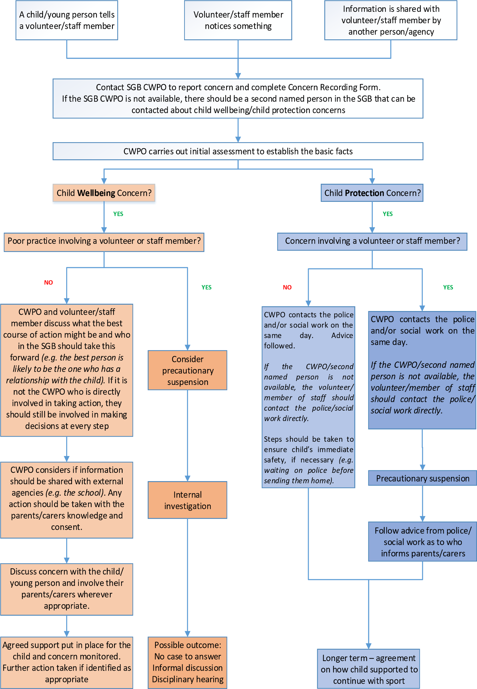

* delete as appropriate to your organisation
* delete/use as appropriate to your organisation

